**Distribute Your App Across a Swarm Cluster**

Edit the **/etc/hosts** file across the two nodes via **gedit** or **vim** and make the following changes:

**172.31.17.73 dockermanager**

**172.31.86.69 dockerworker1**

After modifying the host file with the details mentioned above, check the connectivity with **ping** between all the nodes

* From Docker Manager Host instance

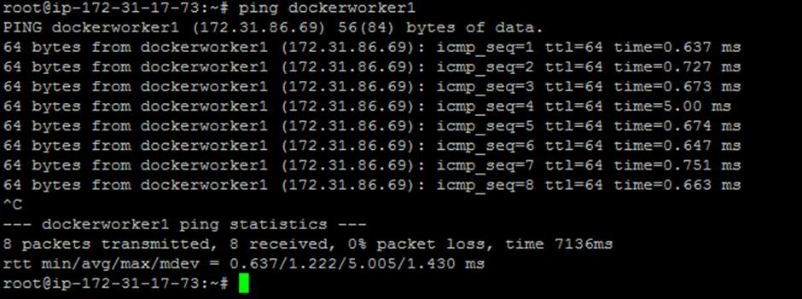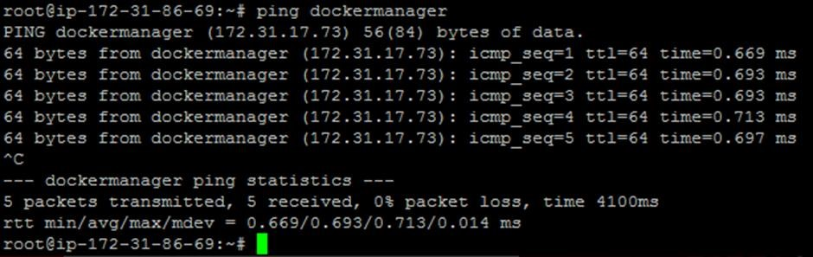

* **docker swarm init --advertise-addr172.31.17.73**

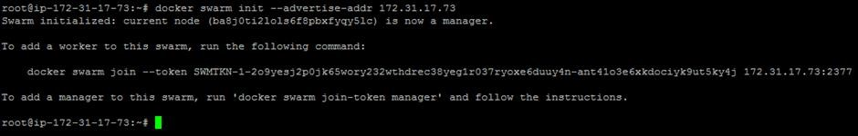

* Once the swarm cluster is initialized, allow the ports mentioned below in security groups





* **docker node ls**



* **docker service create --name webapp --publish 8080:8080 --replicas 2 jocatalin/kubernetes-bootcamp:v1**

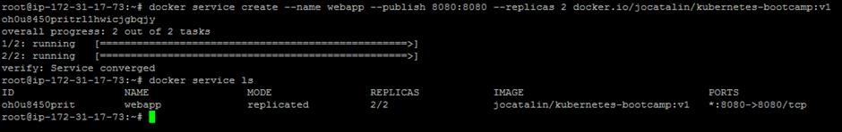

* curl command to see if the application is up and running.

